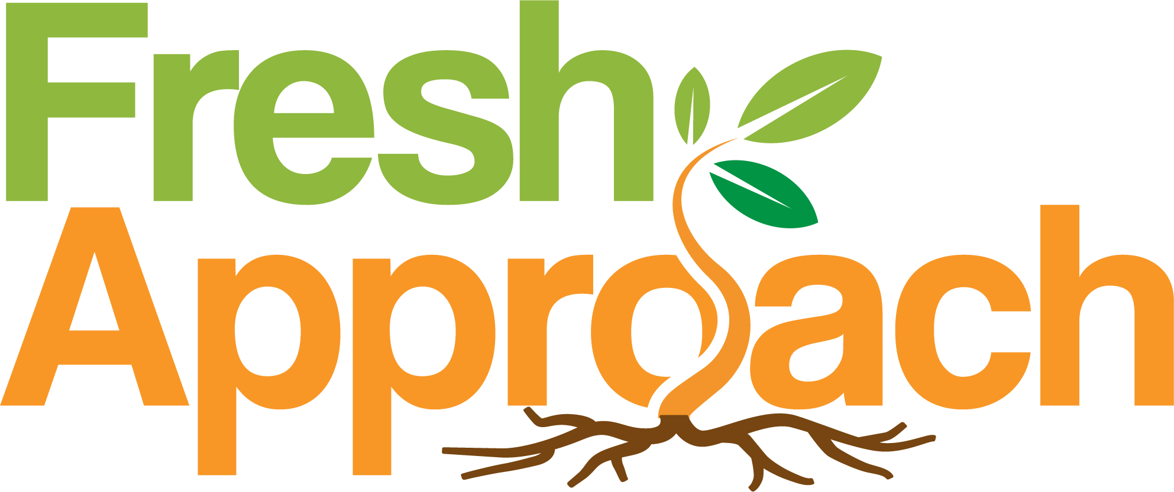
Making Healthy Food More Accessible 5060 Commercial Circle, Ste. C, Concord, CA 94520
in the San Francisco Bay Area (925) 771-2990 | freshapproach.org | programs@freshapproach.org

2026 EPA Community Farmers’ Market TUP Application Operational Letter

- This year, the market will be held from April 1st until November 18th, every Wednesday from 8:30 am to 12:30 pm. The site host is Bloomhouse, located at 2555 Pulgas Ave, East Palo Alto, CA 94303.

- We have four certified farmers selling fresh produce (fruits and vegetables), two vendors selling prepared foods (Hummus and Pasta), one plant vendor, and two small business vendors selling organic products.

- We don't need extra parking space since we can use the parking space on the hosting property.

-Trash reciprocals onsite for food demonstrations.

- We don't have issues with drainage since we don't have runoff water.

- There is a portable restroom on the Bloomhouse property next to the market that is available for the market users.

Sign permit:

We want to add three promotional banners that are 4X8 ft each. We want to place one on the corner fence of Taqueria La Cazuela, The corner fence of Donohue and University, and between Pulgas and East Bayshore cross streets.

